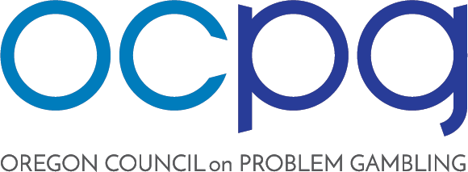

OCPG BOARD MEETING AGENDA
Thursday April 9, 2020 10:00 – 11:30AM

Rescheduled from March 19, 2020

Remote : https://www.gotomeet.me/OregonCouncil 646.749.3122 Access Code: 600-860-245 (audio pin 33#)

- Call to Order (Coe)

- Public Comment (Coe)

- Review Proposed Agenda (Coe)

- Directors discussion/election (Hynes):
  - Ex Officio: Sharon Williams
  - Candidate: Kitty Martz

- Review Minutes of January 23, 2020 (Shaw)

- Old Business:
  - Brief Financial Update (Hynes/Marotta)

- New Business:
  - OCPG Bylaws (Coe/Hynes)
  - Research Institute Concept (Coe)
  - Bank account: Investment discussion (All)

- Legislative Updates (All)

- Informal Reports & Updates as Necessary

- Call for New Business/Future Agenda Items (Coe)
  - Overview of Workforce Development Contract (Coe)
  - Strategic Plan (continued)

- Next Regular Meeting: May 28, 2020 10:00 – 11:30 Location to be determined.
- Adjournment (Coe)

PO Box 30118 | Portland, OR 97294 | www.oregoncpg.org
The Oregon Affiliate of the National Council on Problem Gambling

