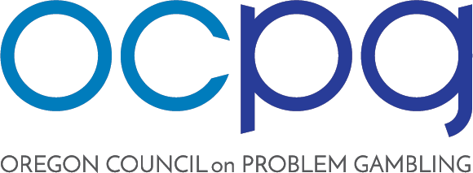

OCPG BOARD MEETING AGENDA
Regular Meeting
Tuesday, March 2, 2021 | 10:30 AM – 12:00 PM

Remote https://us02web.zoom.us/j/82105644229
Dial in: (253) 215-8782

- Call to Order (Coe)
- Public Comment (Coe)

- Review Proposed Agenda (Coe)

- Review Minutes of January 12, 2021 (Martz)

- Old Business:
  - Financial Update (Hynes/Marotta)
  - Strategic Plan (Hynes)

- New Business:
  - Problem Gambling Awareness Month (Hynes)
  - PG Integration Project and Research Agenda (Coe)
  - Legislative Updates (All)
  - Advocacy Committee (TBD)
  - Recruitment & Revenue Committee Report (Coe/Hynes)

- Informal Reports & Updates

- Call for New Business/Future Agenda Items (Coe)
  - Overview of Workforce Development Contract (Coe)

- Upcoming Meetings:
- May 4, 2021
- July 6, 2021
- September 7, 2021
- November 2, 2021

- Adjournment (Coe)

